

**Case study**

**Content Management System**

**August 2019**

**Rahul Yadav**

**Table of Contents**

1 Overview and Background 2

2 Market and microservice landscape 3

2.1 Current Market Approach 3

2.2 New Market Approach 3

3 Contentful concept 3

3.1 Vision 3

4 Use Cases 3

5 Customer Stories 3

6 Contentful Competitive Differentiators 3

7 Plan and pricng 4

# **Overview and Background**

Contentful powers digital experiences for major brands around the globe. Its content infrastructure provides a powerful set of APIs to manage, integrate and deliver content to any device or service. Developers and content creators can build digital products and edit content in parallel, enabling teams to ship faster with the team includes more than 200 people from 45 nations, with offices in Berlin and San Francisco.

Contentful is a content infrastructure. Platform that lets you create manage and distribute content to any platform. Contentful provides total freedom to create content model to decide the type of content user wants to manage.

The company provides RESTful APIs so user can deliver content across multiple channels such as websites, mobile apps (iOS, Android and Windows Phone) or any other platform user can imagine (from Google Glass to infinity)..

Contentful is an efficient tool for creating and managing your content online, either alone or in team. Assign custom roles and permissions to team members, add validations depending on the kind of content you have to insert and add media such as images, documents, sounds or video.

The infrastructure whose interface was designed so that everyone, with or without a technical background, can use it. If you use Contentful without writing code, you can add and edit content types, and also add and manage actual content. In other words, you can do the work of an editor or content strategist.

The company provide you with a content infrastructure for your projects. If you are building a website you can use Contentful to manage its content.

The infrastructure provides you to manage video, music, images, text, code or structured documents – anything can be put in there, appropriately structured, and created by multiple editors.

To actually display your content outside of Contentful, user will need to either create code or work with an agency, freelancer or someone who can develop a platform. They can help by creating a website, a mobile app and many other experiences based on user’s content. Needless to say, User’s content will be shared between all of the platforms so that you only need to create and manage it once.

## **Market and microservice landscape**

Now a days Companies are building more software than ever before to connect with their customers through websites, mobile apps, on-site, in-home, and beyond. Digital market is becoming stronger day by day.

Growing in the range of digital products transformed the business model, now building business, brands, revenue, customer loyalty, and shareholder means building software.

Companies need to create several digital products to reach more customers, but creating several data infrastructure for different channels is also another challenging task for them.

Innovators are creating across functional digital team that works on agile, reusable, modular stack for launching digital products & experimenting in new channels.

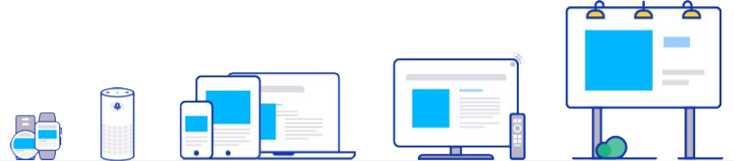

## **Current Market Approach**

Traditional CMS is slowing down the modern digital teams, there development architecture is more complex that includes data management system and data presentation system in a common environment. To manage and having rigid data model that prevent reusability and creates content silos, that need more specialized developer resources, longer and more involved development time frames, can have SEO and marketing operations implications.

The below are the 3 main problems traditional CMS is facing.

* **Rigid data models**: Traditional CMS prevents reusability, that increase development time and development cost and that only allows you to create web bases pages only.
* **Monolithic Suits**: Development needs heavy customizations and specific tools that exists in your environment suit, tightly coupled architecture needs work for overall structure when requires modification.
* **Legacy workflow**: Modern market requirement need rapid iterations and changes that can interacts the other services easily. Traditional CMS doesn’t fir modern software delivery pipelines.

Today’s market need something fast, Flexible, and easy to adopt architecture that can help them to compete in fast growing market. Traditional or coupled architecture is restricting user to explore the new ways to connect to the customers.

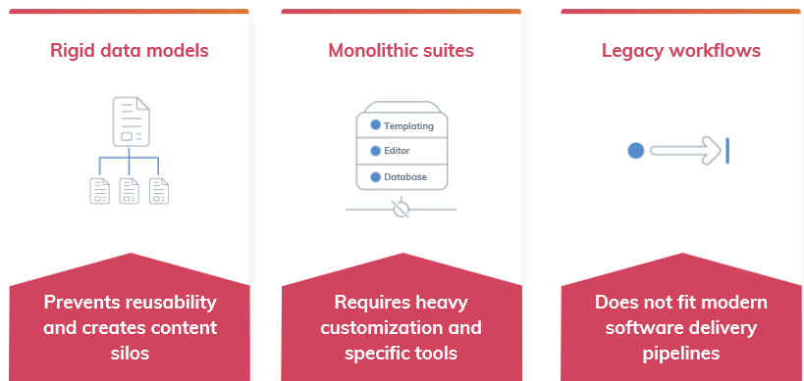

## **New Market Approach**

A new delivery platform provides agility, a reusable, modular stack for launching digital products & experimenting in new channels. New delivery team requires a blue print for launching new products or digital touch points with a modular tech stack, a team business units that select the modules of the stack they need for each new digital product they launch and Digital Products that Engage customers, test new technologies or channels, and incorporate successes back into core stack for use across teams.

Content infrastructure is a new way that helps is achieving the new approach of the market. That modern stacks include highly-specialized platforms that simplify & accelerate development.

Contentful is providing platform as a service for building and engaging digital products: websites, apps, devices and beyond.

New Architecture is based on micro services that render fast and easily incorporate anywhere user wants that is more master and flexible approach to server the faster growing digital market.

How this approach is contributing the new digital world.

* **Structured Content:** New approach produce more reusable component that incorporates in faster development and cost effective and is independent of channels or language.
* **Decoupled Architecture:** Data is stored and managed on some another cloud based storage makes it easier to manage and connected to other platform.
* **Agile workflows:** New approach has agile workflows that can integrate with digital delivery workflows for fast launches and iteration. Micro services allows the user to ease creation and integration of modules.

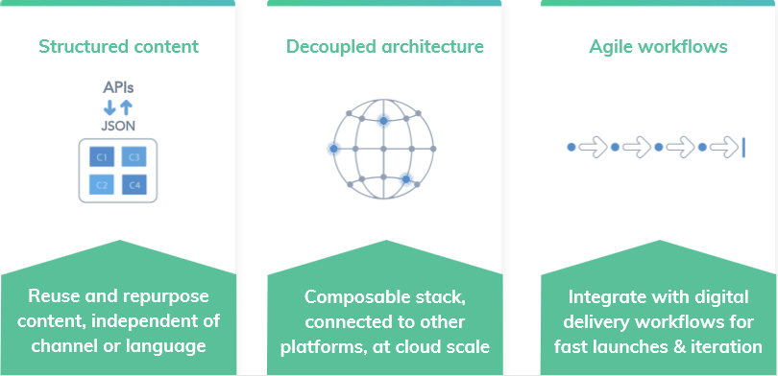

# **Contentful concept**

*It’s time for a new way: content infrastructure*

Modern stacks include highly-specialized platforms that simplify & accelerate development

Contentful is not a CMS. It is Platform as a service for building engaging digital products like websites, apps, devices, and beyond.

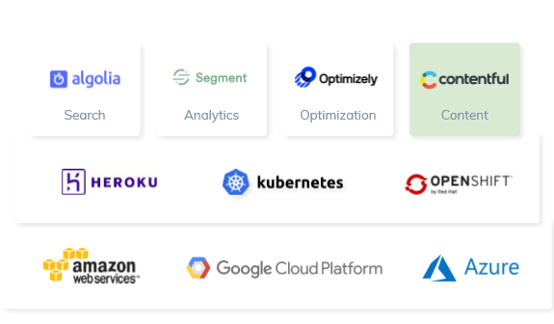

The main concept of this approach is using micro services that easily can collaborate with others and solve a business logic, which is ease to develop and manage. If one stop working other can contribute its service to manage the crash of the application.

## **Vision**

Innovative companies will assemble modular stack, with a content hub at a center. The new approach works with stacks rather than with suits. Contentful works as hub at a center to manage data and different services all revolving around it.

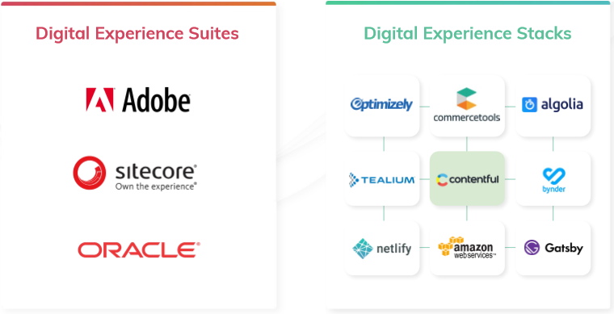

Suits works with dependencies and includes the services that user doesn’t need. Contentful creates a micro services architecture that integrate the services from other environment and contributes to a business requirement that approach make the software development more manage agile and flexible.